* Snapshot testing
  + It will create the replica of the component in their own coding way.
  + We are the deploying in the production with by mistake small test or other changes which we are not intended to, then it will compare it with the previous replica of the component and warns us that our current version has changed with respect to the previous version.
  + So we can correct our code or we can make new snapshot if we intentionally did that change.
* To create the snapshot:
  + We need to write the following code in the test:
    - 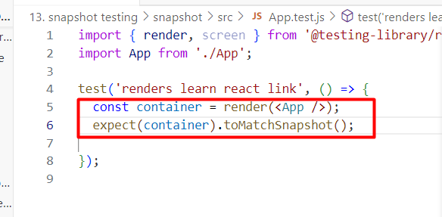
  + After that we will run “npm run test”, then automatically one new folder is created.
    - 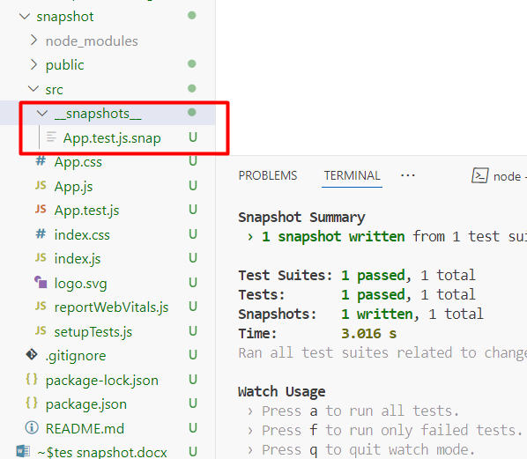
  + It contains the replica of the <App /> component.
* Now if we change anything on the app component and run the test again, then:
  + 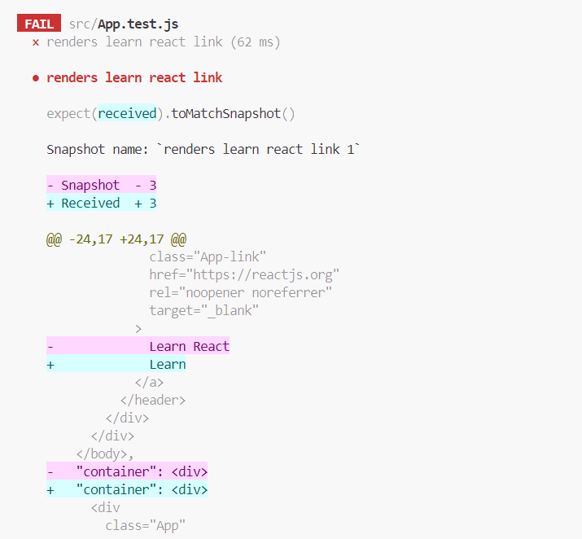
  + 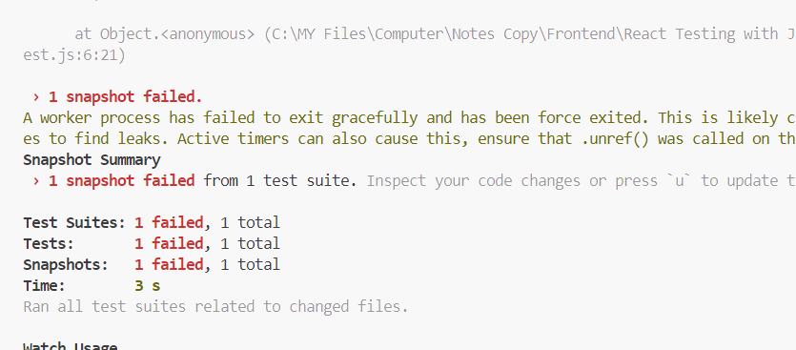
  + And suppose if we intentionally did these changes, then we will write “u”
    - 